Final Major Project
Developing a Business System
Food4Need – Feeding Communities, Reducing Waste Application

Course Code: INFO8003

Instructor: Prof. Randall Kozak

Conestoga College Institute of Technology and Advanced
Learning

Submitted By:

Anamika Rawat (9087089)
Sukhpal Kaur (9011033)

Submitted On:

05 Dec 2025

Using a collaborative tool
For the Food4Need project, the team used GitHub as a cloud-based collaborative platform to organize, store, and manage all project materials. Both team members, Anamika Rawat and Sukhpal Kaur, actively contributed by uploading their respective work, including research, use cases, diagrams, Agile planning, and documentation. Each commit clearly reflects the tasks completed by the individual team member.
All project materials can be accessed in the repository via the following link:
GitHub Repository: https://github.com/anamika9898/Food4Need

Forming a Development Team

Task Distribution Table Overview
This table outlines the various tasks involved in the Food4Need project. Although the team consists of only two members, all tasks are collaborative. Each member has a primary responsibility for specific aspects of a task to ensure accountability, efficiency, and professional management of the project.

Tasks | Assigned Members | Primary Responsibilities
Brainstorming | Anamika Rawat, Sukhpal Kaur | Generate ideas for features, functionality, and innovative solutions for the app.
Research | Anamika Rawat, Sukhpal Kaur | Conduct market analysis, study similar apps, gather information on social-benefit organizations and sustainability practices.
Business Model | Anamika Rawat, Sukhpal Kaur | Develop a business model for the app, including potential revenue streams and partnerships with local food banks and organizations.
Market Analysis & Personas | Anamika Rawat, Sukhpal Kaur | Identify target users, create personas representing donors, volunteers, and food bank staff.
Use Cases | Anamika Rawat, Sukhpal Kaur | Develop functional requirements, detailed use cases, and flow of interactions between users and the system.
Entity Relationship Diagram (ERD) | Anamika Rawat, Sukhpal Kaur | Identify entities, relationships, and attributes for the database design of the application.
Class Diagram | Anamika Rawat, Sukhpal Kaur | Model the object-oriented structure including classes, attributes, methods, and inheritance.
Content Plans | Anamika Rawat, Sukhpal Kaur | Design text, input forms, buttons, and features for each screen of the app.
Prototype Mockups | Anamika Rawat, Sukhpal Kaur | Create screen mockups using Figma or similar tools for chosen use cases.
Code Development | Anamika Rawat, Sukhpal Kaur | Plan the coding tasks, simulate implementation, and prepare the development strategy (even if actual coding is not done).
Testing (Unit, Integration, Regression, Acceptance, Usability) | Anamika Rawat, Sukhpal Kaur | Plan testing procedures for the system to ensure quality, usability, and correctness.
Documentation | Anamika Rawat, Sukhpal Kaur | Compile all research, diagrams, use cases, Agile plan, and project deliverables into the final report.

Scrum Roles Table Overview
This table defines the Scrum development roles for the project. The Product Owner is responsible for defining the product vision and prioritizing tasks, while the Scrum Master facilitates agile processes, manages sprint planning, and ensures smooth team collaboration. These roles guide the team through an organized, iterative development process.
Role | Assigned Member | Responsibilities
Product Owner | Anamika Rawat | Define product vision, prioritize tasks, decide on key features, and manage project scope.
Scrum Master | Sukhpal Kaur | Facilitate sprint planning, track progress, resolve blockers, and ensure the team follows Agile practices.

Preliminary Research
The motivation behind Food4Need is anchored in the global imbalance between massive food waste and rising food insecurity. According to the United Nations Environment Programme (UNEP), nearly one-third of all food produced for human consumption—approximately 1.3 billion tonnes per year—is lost or wasted. This level of waste represents not only a loss of valuable resources but also contributes to environmental degradation through increased greenhouse gas emissions and the unnecessary use of land, water, and energy (UNEP).
At the same time, food insecurity in Canada continues to escalate. The 2025 HungerCount Report by Food Banks Canada indicates that monthly food bank visits reached approximately 2.2 million in March 2025, the highest figure recorded to date. The report also notes that food bank usage has nearly doubled since 2019, reflecting rising living costs and widening social inequalities (Food Banks Canada; Newswire; Pollara Strategic Insights).
These two conditions—global food waste and growing domestic demand—highlight a serious systemic gap. Large quantities of surplus food are being discarded even as more individuals rely on community food supports. Current food redistribution mechanisms remain fragmented, often relying on manual coordination, outdated processes, or separate organizational systems that lack real-time communication and transparent tracking.
A review of recent literature and reports identified several challenges that hinder efficient redistribution:
- Surplus food frequently goes to waste because donors lack a fast, accessible method to broadcast availability in real time.
- Shelters and charitable organizations are increasingly overwhelmed and often unable to access surplus food quickly enough to meet demand (CP24; Feed Ontario).
- Limited transparency, inconsistent verification, and logistical uncertainties discourage many potential donors.
- Perishable food is especially vulnerable to spoilage when communication and pickup systems are slow or uncoordinated.
In response to these challenges, there is a clear social, environmental, and operational need for a centralized, location-aware digital system that connects donors, shelters, food banks, and volunteers. Food4Need addresses this need by enabling real-time posting of surplus food, geolocation-based matching, expiry alerts, and transparent tracking. Such an integrated solution can improve redistribution efficiency, reduce waste, and strengthen community support systems.
In summary, preliminary research strongly demonstrates that the conditions in Canada and worldwide justify the development of Food4Need. The evidence confirms that both food waste and food insecurity are at critical levels, and a modern, technology-driven solution has the potential to deliver meaningful impact.

Brainstorming
The brainstorming phase focused on identifying features, user roles, benefits, and long-term impact for Food4Need. The goal was to design a system that is user-friendly, socially responsible, and operationally effective.

Key Brainstormed Features

Real-time Donation Listings
- Donors can quickly post available food, including type, quantity, expiry date, and pickup window.
- Benefit: Reduces spoilage and ensures shelters receive timely donations.
- Rationale: Quick listing reduces wasted food that occurs due to slow communication {Too Good To Go; Olio}.

Live Map with Geolocation
- Interactive map shows donor locations, shelters, urgent requests, and volunteer drivers.
- Benefit: Enables efficient planning and reduces transportation time and costs.
- Rationale: Location-based matching optimizes food recovery and distribution {ReFED}.

Expiry Tracking & Notifications
- System alerts donors when perishable food is approaching expiry and suggests donation options.
- Benefit: Minimizes food loss and increases recovery of high-risk perishable items.
- Rationale: Studies indicate timely notifications increase donations of perishable items {Second Harvest}.

Claiming System and Scheduling
- Shelters can claim donations and coordinate pickup or delivery times with donors or volunteers.
- Benefit: Reduces missed donations and improves accountability.
- Rationale: Structured claim workflows improve reliability and prevent duplication.

Transparency and Feedback System
- Donors receive confirmation and feedback from shelters, including ratings and comments.
- Benefit: Builds trust and encourages repeat donations.
- Rationale: Positive feedback increases engagement and donor retention {Olio}.

Admin Governance & Verification
- Admin verifies new users and approves donation listings to ensure safety and legitimacy.
- Benefit: Prevents fraud, ensures compliance, and maintains credibility.
- Rationale: Oversight reduces risks in the donation process and encourages participation.

Event Management
- Admins can create campaigns, charity events, and food drives with RSVP tracking and notifications.
- Benefit: Increases community engagement and awareness of donation opportunities.
- Rationale: Structured events concentrate resources and volunteer efforts effectively.

Community Impact Dashboard
- Displays metrics such as total food saved, meals provided, and active users.
- Benefit: Shows tangible results, motivates donors, and helps attract partners/funders.
- Rationale: Transparent impact metrics improve accountability and reporting {ReFED}.

Volunteer Integration (Future)
- Volunteers assist with pickup and delivery for donors unable to transport food.
- Benefit: Expands reach and flexibility of the redistribution system.
- Rationale: Community engagement enhances scalability and ensures all available food is recovered.

Educational & Safety Resources
- Tips and guidelines for safe food handling, storage, and donation procedures.
- Benefit: Reduces health risks and informs users about best practices.
- Rationale: Safety education improves compliance and donor confidence.

Research – Web Market Analysis

Existing Applications and Platforms
Several apps and platforms currently address food waste and surplus food redistribution, but each has limitations when it comes to donation-focused workflows:

Too Good To Go
- Mobile app connecting restaurants, cafés, and retailers with consumers to sell surplus food at reduced prices.
- Strengths: Reduces food waste, large user base, simple interface.
- Limitations: Focused on consumer purchases, not charitable donations. No integration with shelters or structured donation verification.
Screenshot:
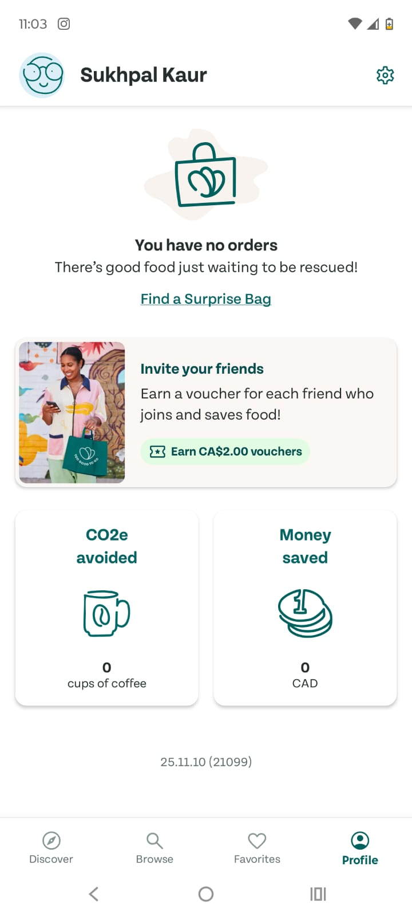

Olio
  - Community-based app for sharing surplus food and other items with neighbors for free.
  - Strengths: Encourages local sharing, reduces household waste, free for all users.
  - Limitations: Peer-to-peer only, no integration with food banks or shelters, lacks admin verification, expiry tracking, and delivery scheduling.
Screenshot:
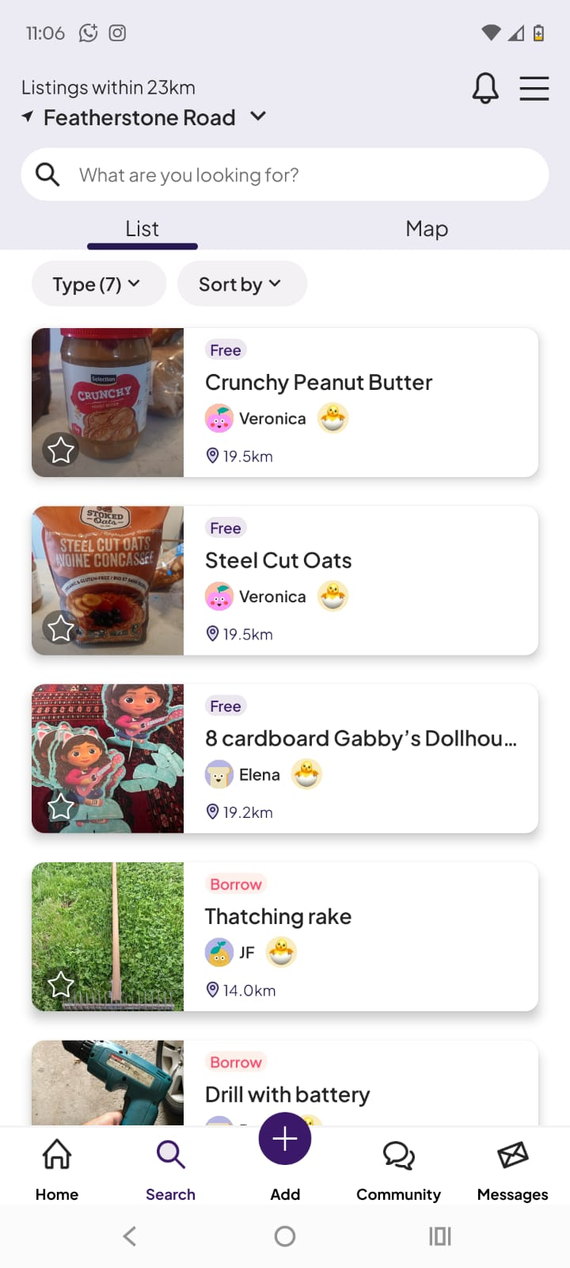

Local Food Bank or Charity Platforms
  - Many food banks and shelters use websites, email, or phone-based systems to coordinate donations.
  - Strengths: Trusted organizations, targeted help for people in need.
  - Limitations: Manual coordination, no real-time updates, fragmented processes, limited reach to new donors.
Screenshot:
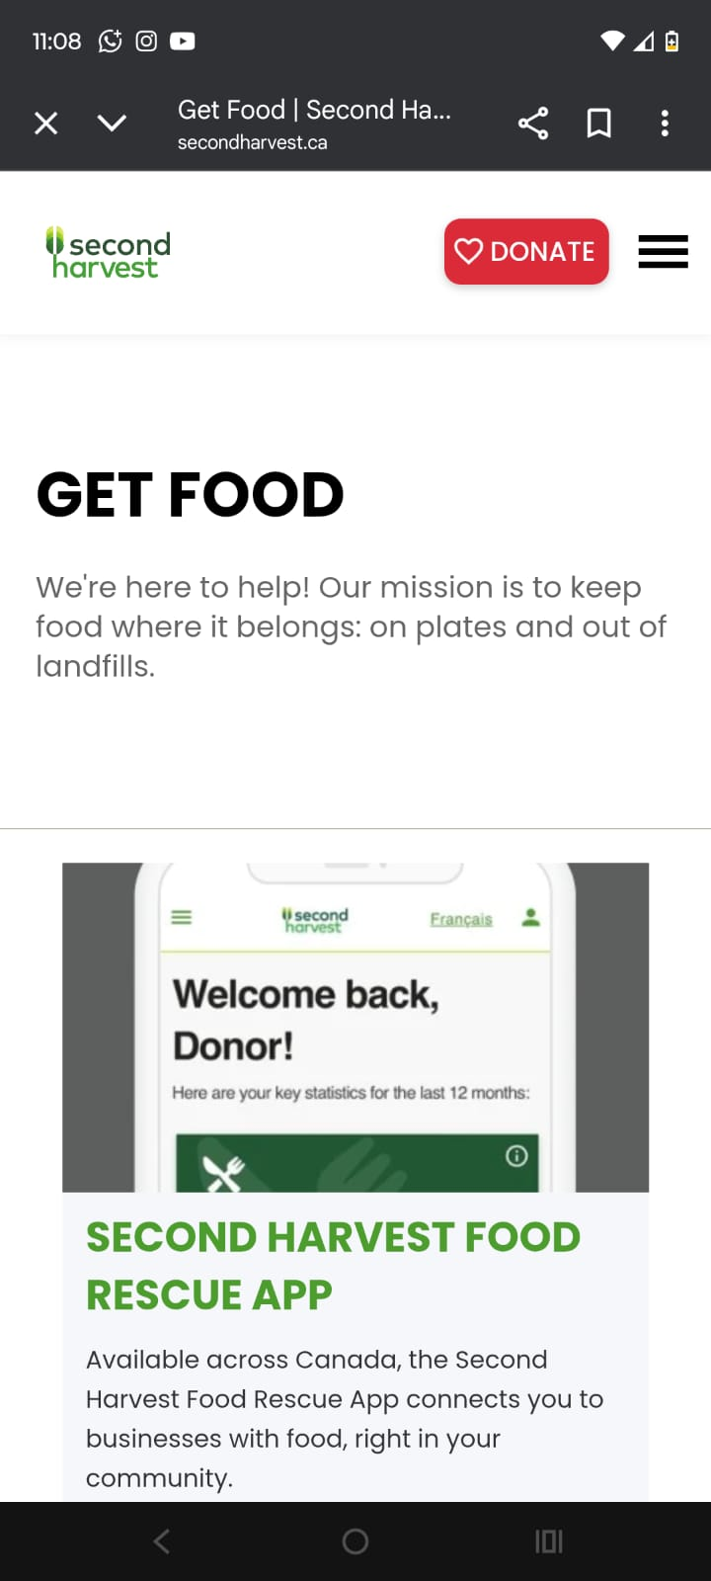

Current Methods People Use
- Informal drives, phone calls, emails, and local social media groups to arrange donations (CP24; Feed Ontario).
- Apps like Olio or Too Good To Go for surplus food redistribution, but these primarily serve consumers or peer-to-peer sharing (ReFED).
- Traditional charity websites or spreadsheets for food bank management, often slow and uncoordinated (Second Harvest).

Features Needed by Food4Need
Based on gaps in existing apps, Food4Need requires the following features:
- Real-time Donation Listings: Donors post surplus food quickly to prevent spoilage.
- Live Map & Geolocation: Shelters and volunteers locate nearby donations.
- Expiry Tracking & Notifications: Alerts for perishable items approaching expiry.
- Claiming & Scheduling System: Shelters can claim donations and schedule pickups or deliveries.
- Admin Governance & Verification: Admin approval for users and donations ensures trust.
- Transparency & Feedback: Donors receive feedback from shelters to encourage engagement.
- Event Management: Admin can create campaigns, food drives, or charity events.
- Community Impact Dashboard: Shows total food saved, meals provided, and active users.
- Volunteer Integration (Future): Volunteers assist with transport for donations (Second Harvest; ReFED).

How Food4Need Differs From Existing Apps
- Unlike Too Good To Go, Food4Need focuses on donations to shelters, not consumer purchases.
- Unlike Olio, it integrates verification, scheduling, and accountability.
- Unlike manual charity coordination, it provides real-time visibility, geolocation, expiry tracking, and feedback, improving efficiency and safety.
- Offers a social and environmental impact dashboard, which is missing in other apps (ReFED; Second Harvest).

Why Developing Food4Need Makes Sense
- Rising Food Insecurity: Increasing food bank visits indicate strong demand for efficient donation systems (Food Banks Canada).
- High Food Waste Levels: Globally, 1.3 billion tonnes of food are wasted annually (UNEP), highlighting the need for recovery solutions.
- Technology Feasibility: Smartphones enable real-time coordination and geolocation matching for donors, shelters, and volunteers.
- Market Gap: No existing app integrates donation-to-shelter workflows, verification, expiry tracking, logistics, and social impact measurement in a single platform.
- Scalability & Sustainability: Food4Need can grow to include corporate partnerships, volunteers, and community campaigns, creating long-term impact (ReFED; Second Harvest).

Description
Food4Need is a mobile and web-based application designed to reduce food waste while simultaneously supporting food-insecure communities. The platform connects donors—including households, restaurants, and grocery stores—with shelters, food banks, and volunteers in real time. This creates an efficient, transparent, and socially responsible food redistribution ecosystem (UNEP, 2021; Food Banks Canada, 2025).
The application serves both social and business purposes. Socially, it addresses hunger and strengthens community engagement; environmentally, it reduces food wastage and the associated carbon footprint (UNEP, 2021). From a business perspective, Food4Need enables partnerships with retailers, NGOs, and local governments, providing a scalable solution that combines social impact with operational sustainability (Second Harvest, 2022).
The design emphasizes ease-of-use, efficiency, transparency, and measurable social impact, ensuring that surplus food is redirected promptly to those in need while donors receive feedback and recognition for their contributions (ReFED, 2020).

Preliminary List of Desirable Features
- Real-time Donation Listings: Donors can post available food items with type, quantity, expiry date, and location (Olio, 2023).
- Live Map & Geolocation: Shelters and volunteers can locate nearby donors and urgent donations (Too Good To Go, 2023).
- Expiry Tracking & Notifications: Alerts for perishable items approaching expiry to prevent food spoilage (Second Harvest, 2022).
- Claiming & Scheduling System: Shelters can claim donations and arrange pickups or deliveries (Food Banks Canada, 2025).
- Admin Governance & Verification: Admin approval for users and donations ensures legitimacy and trust (ReFED, 2020).
- Transparency & Feedback: Donors receive feedback and ratings from recipients to increase engagement (Second Harvest, 2022).
- Event Management: Admin can organize campaigns, food drives, and charity events (Feed Ontario, 2023).
- Community Impact Dashboard: Displays metrics such as total food saved, meals served, and volunteer participation (UNEP, 2021).
- Volunteer Integration (Future): Volunteers assist with logistics and delivery of donated items (ReFED, 2020).
- Educational Resources: Tips on food preservation, sustainability practices, and community involvement (Second Harvest, 2022).

Possible Revenue Streams
- Partnerships with Food Retailers & Restaurants: Paid listings or subscription-based partnerships for surplus food management (Too Good To Go, 2023).
- Sponsorship from NGOs or Corporations: Brand sponsorship for social impact campaigns and food drives (ReFED, 2020).
- Premium Features for Donors or Volunteers: Advanced analytics, donation tracking, or recognition badges (Olio, 2023).
- Government Grants or Social Innovation Funding: Funding from municipal or federal programs promoting sustainability and food security (Food Banks Canada, 2025).
- Event Fees or Donations: Crowdfunding campaigns, charity events, or in-app donations to support logistics and app maintenance (Feed Ontario, 2023).

Future Goals / Extensions
- Volunteer Routing & Logistics Optimization: AI-assisted routes for pickups and deliveries to maximize efficiency (Second Harvest, 2022).
- Corporate Partnerships & Bulk Donations: Integration with large retailers or producers for bulk surplus donations (ReFED, 2020).
- Expanded Geographic Coverage: Scaling to additional regions or nationwide deployment (Food Banks Canada, 2025).
- Educational & Community Engagement Modules: Gamification, awareness campaigns, and workshops (UNEP, 2021).
- Integration with Local Services: Health organizations, schools, and shelters to broaden social impact (Feed Ontario, 2023).
- Advanced Data Analytics: Predictive analytics for donation patterns, expiry management, and impact forecasting (Second Harvest, 2022).
- Adaptation for Other Resource Sharing: Extending to non-food items like clothing or furniture (Olio, 2023).

Alignment with Theme
Food4Need aligns with the course theme of “Developing a Business System with Social and Environmental Impact”. It integrates technology, logistics, and social responsibility to create measurable outcomes, reducing food waste and supporting vulnerable populations (UNEP, 2021; Food Banks Canada, 2025; Second Harvest, 2022).

References

Technical Requirements
Food4Need – Feeding Communities, Reducing Waste

1. Special Device Hardware Features
Food4Need is designed to run on standard smartphones, tablets, and potentially web browsers, without requiring specialized hardware. However, certain common device features are essential for full functionality:
- GPS / Location Services:
The app relies heavily on geolocation to match donors, shelters, and volunteers in real time. GPS enables live maps, nearby donation alerts, and route optimization for pickups and deliveries (Olio, 2023).
- Camera Access:
Donors can upload images of food items to improve accuracy of listings and verification. Photos also provide visual proof for shelters and admins, enhancing transparency (Too Good To Go, 2023).
- Push Notifications:
Critical for alerting donors and shelters about urgent donations, food approaching expiry, or claimed items, ensuring timely action and reduced waste (Second Harvest, 2022).
- Internet Connectivity:
Required for real-time updates, cloud synchronization, and communication between all users. Offline mode could be limited to viewing previous donations or records.
Discussion:
These are all standard features on modern devices, so the app does not demand any specialized hardware. However, functionality may be reduced for users with older devices lacking GPS, camera, or stable internet connectivity.

2. Special Input Controls
The app is designed for simple, intuitive input to accommodate a wide range of users, including non-technical donors and volunteers:
- Form-based Inputs: Dropdowns, checkboxes, and text fields for entering food type, quantity, expiry date, and location. This ensures structured and consistent data collection.
- Interactive Map Controls: Users can place pins for donor or shelter locations, zoom and pan to view nearby activity, and tap to select donations or pickup points.
- Claim & Pickup Buttons: One-touch interface for shelters to claim donations and schedule deliveries.
- Swipe / Tap Feedback Controls: Quick feedback or rating system for donors and shelters to provide reviews and comments.
- Voice Input (Optional Future Feature): Could assist users with disabilities or when manual entry is inconvenient (UNEP, 2021).
- Push Notification Interactions: Actionable notifications allow users to respond directly from alerts, e.g., claim donation or confirm pickup.
Discussion:
The app does not require specialized controllers or hardware inputs beyond standard touchscreen interaction. These controls are designed for accessibility, simplicity, and rapid response.

3. Contextual Constraints and Advantages
Constraints:
- Internet Dependence: Real-time geolocation, notifications, and database updates require connectivity. Users in rural or low-bandwidth areas may face reduced functionality.
- Device Limitations: Older smartphones may struggle with map rendering, notifications, or photo uploads.
- Privacy and Security: Handling personal and location data requires adherence to privacy regulations (e.g., PIPEDA in Canada, GDPR if expanded globally).
- Food Safety & Regulatory Compliance: Users must handle perishable items safely; the app should include reminders for proper food storage and regulatory guidance.
Advantages:
- Widespread Smartphone Adoption: Most target users have GPS-enabled devices capable of running the app.
- Real-Time Location Context: Geolocation allows efficient matching of donors and shelters, reducing food spoilage and transport time.
- Community Engagement: Mobile notifications, maps, and feedback systems enhance volunteer participation and donor retention.
- Scalability: Cloud-based infrastructure allows for future growth to larger regions or nationwide use without significant changes in hardware requirements.
- Environmental Impact: Real-time coordination reduces food waste and associated greenhouse gas emissions, aligning with sustainability goals (UNEP, 2021; Second Harvest, 2022).

Personas
We have chosen three key personas to represent our target users
Link for persona:
https://www.canva.com/design/DAGzXFo6KjU/xv7nU_sU1Kf4tQUFD6ECdw/edit?utm_content=DAGzXFo6KjU&utm_campaign=designshare&utm_medium=link2&utm_source=sharebutton

Persona 1: Marketing Specialist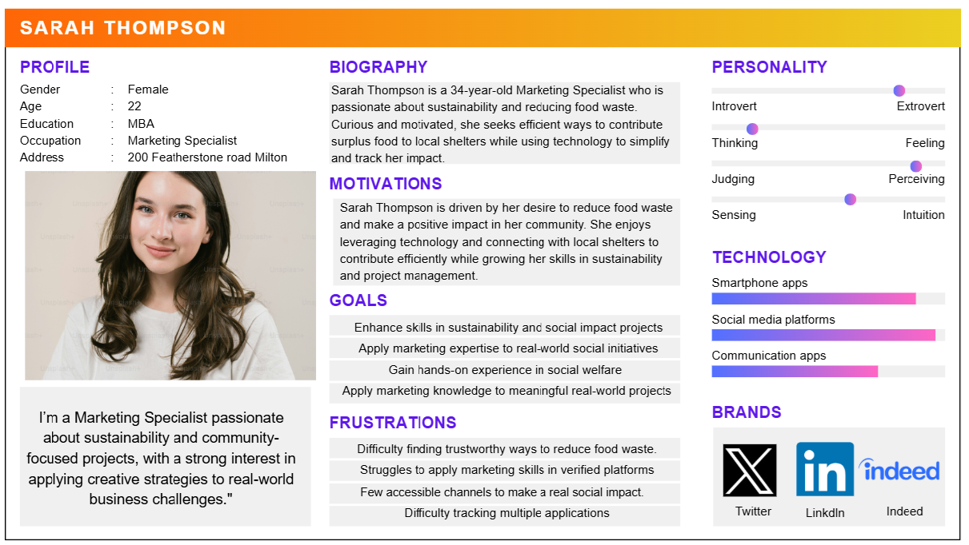

Persona 2: Shelter Coordinator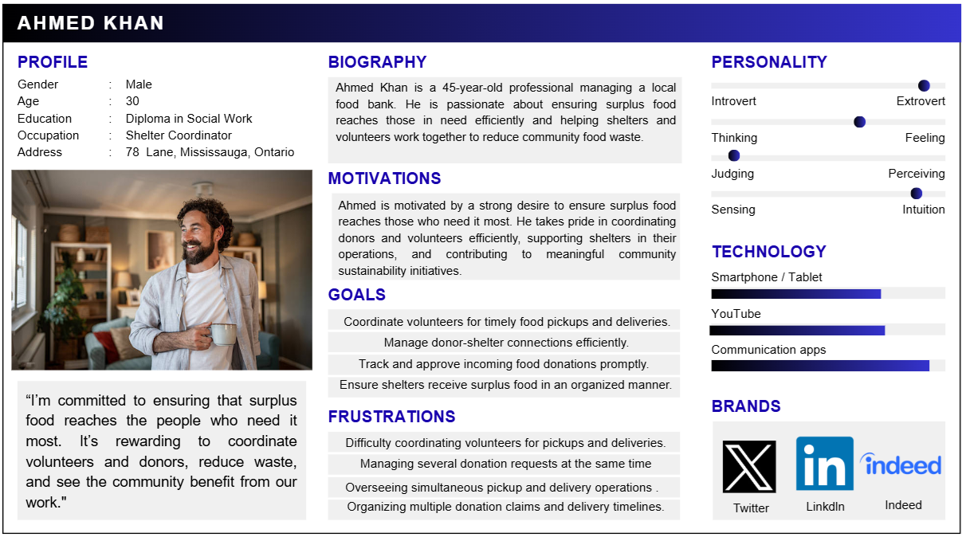

Persona 3: Volunteer Administrator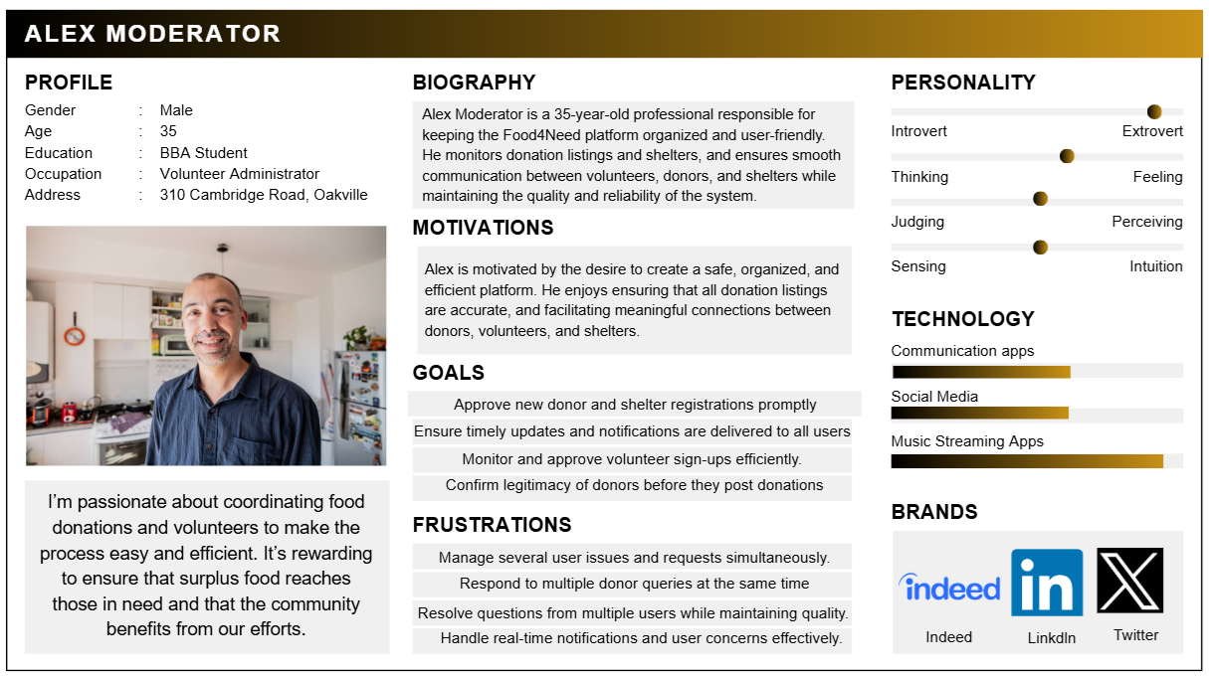

Use Cases

Use Case List Description
Use Case Name | Description
Register / Login - User | Donors and Shelters can create an account and log in to access app features.
Register / Login - Admin | Admin can log in to manage the system and perform administrative tasks.
Manage Profile | Users (Donor, Shelter, Admin) can update personal details, contact info, and preferences.
Post Food Donation Listing | Donors can list food items available for donation with quantity, type, and expiry.
View Available Donations | Shelters can see nearby available donations posted by donors.
Claim Donation | Shelters can claim a donation for pickup or delivery.
Food Expiry Notification | System notifies donors or shelters about perishable food nearing expiry.
Live Map View | Users can see a live map showing nearby donors, shelters, and urgent donation needs.
Feedback / Review | Donors and Shelters can leave feedback or reviews on donation and delivery experiences.
Manage Users | Admin can manage user accounts, approve or deactivate registrations.
Report / Issue Handling | Admin can view and handle system or user-reported issues.
Create/Edit/Delete Events | Admin can manage upcoming events, announcements, or campaigns.
Approve Donation Listings | Admin can approve or reject donation postings before they are visible to shelters.
Approve Shelter/Donors Registrations | Admin can approve or reject new user registrations for the platform.

Use Case Diagram
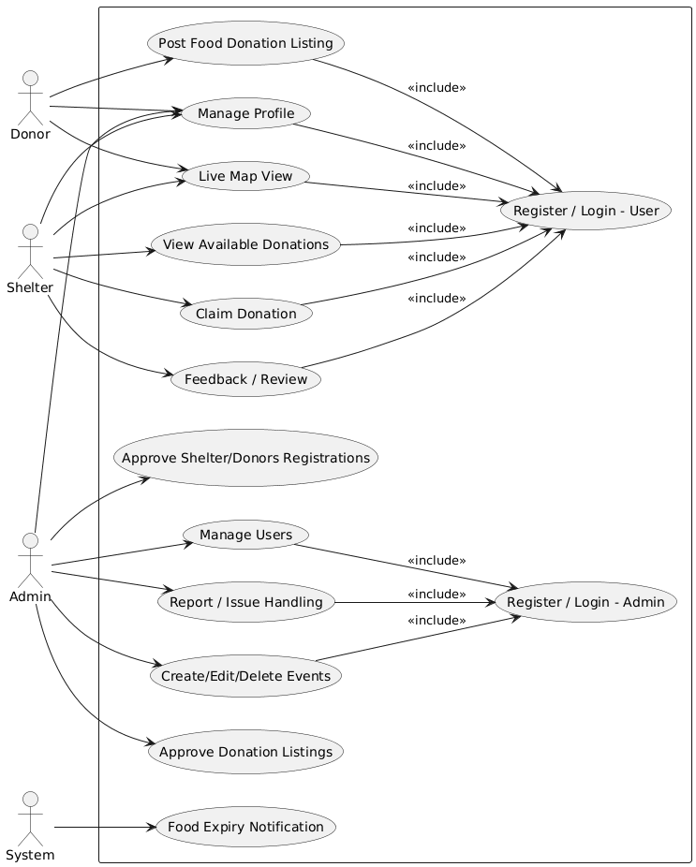

Use Case Description

1. Post Food Donation Listing
Field | Description
Use Case Name | Post Food Donation Listing
Actor | Donor
Description | Allows a donor to post available food items for donation, including type, quantity, expiry date, and location, and send it to review.
Pre-condition | Donor is logged into the application with an active profile.
Post-condition | Donation is successfully submitted; once approved by admin, it becomes visible to shelters.
Main Flow of Events | Actor Action | System Response
Main Flow of Events | 1. Logs into the application  2. Navigates to “Post Food Donation” section  3. Fills in donation details: type, quantity, expiry, location  4. Submits the donation  5. Receives approval notification (optional) | 1. Validates credentials and grants access to the dashboard  2. Displays donation form  3. Validates data and allows submission  4. Notifies admin for approval and stores donation  5. Updates donation status to “Approved” and makes it visible to shelters

2. Claim Donation
Field | Description
Use Case Name | Claim Donation
Actor | Shelter
Description | Allows a shelter to claim approved food donations posted by donors and optionally schedule pickup or delivery.
Pre-condition | Shelter is logged into the application and the donation is approved.
Post-condition | Donation is successfully claimed; donor is notified; donation status is tracked.
Main Flow of Events | Actor Action | System Response
Main Flow of Events | 1. Logs into the application  2. Views available donations.  3. Selects a donation to claim.  4. Confirms claim. | 1. Validates credentials and grants access to the dashboard  2. Displays all approved donations with details.  3. Shows detailed information about the donation  4. Updates donation status to “Claimed” and notifies donor.

Activity Diagram
Use Case: Post Food Donation Listing
Actor: Donor

Activity Flow:
- Start – The process begins when a donor decides to donate surplus food.
- Login: Donor logs into the Food4Need app using credentials.
- Navigate to Donation Section: Donor selects the “Post Food Donation” option from the dashboard.
- Enter Donation Details: Donor inputs required information, including:
- Food type (e.g., fruits, vegetables, packaged goods)
- Quantity of each item
- Expiry date of perishable items
- Pickup/delivery location (linked to MapLocation)
- Submit Donation: Donor clicks submit to send donation for processing.
- System Validation:
- Checks that all fields are filled correctly and data is consistent.
- If invalid: system displays an error message → donor corrects inputs → returns to step 4.
- If valid: donation is sent to Admin for approval.
- Admin Approval:
- Admin reviews the donation listing for completeness, eligibility, and safety standards.
- If approved: donation becomes visible to shelters and eligible volunteers.
- If rejected: donor receives notification with rejection reason and guidance.
- Shelter Interaction: Shelters view the approved donation listing on the platform.
- Claim Donation (Optional): Shelter claims the donation and schedules pickup or delivery. Donation status is updated to “Claimed.”
- Donor Confirmation: Donor receives notifications confirming approval, claims, and any feedback from shelters.
- End – The donation process is completed successfully.

Activity Diagram:
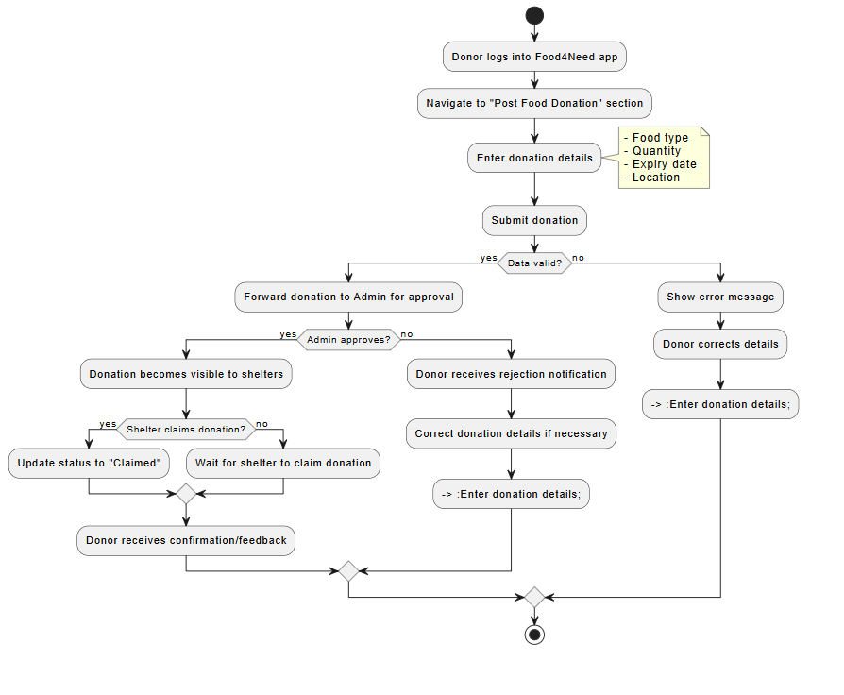

Entities
This table presents the core entities of the Food4Need application, detailing their attributes and explaining their purpose in supporting the donation and redistribution process.

Entities Table:
Entity Name | Attributes | Description / Notes
Donor | donorID, name, email, password, contactNumber, address, organizationName | Represents a user who posts food donations. Includes personal and organization details for identification and communication.
Shelter | shelterID, name, email, password, contactNumber, address, capacity | Represents shelters or food banks that claim and receive donations. Capacity attribute helps manage allocation of resources.
Admin | adminID, name, email, password, contactNumber, address, role | Responsible for managing user accounts, approving donations, events, and ensuring platform governance.
FoodDonation | donationID, foodType, quantity, expiryDate, status, location (MapLocation) | Contains details of each food donation, including type, quantity, expiry date, status (Pending, Approved, Claimed), and geographic location.
MapLocation | latitude, longitude, address | Represents the geographic location for donations, donors, and shelters to enable live map tracking and routing.
Event | eventID, eventName, startDate, endDate, description | Represents organized campaigns, food drives, and community events to facilitate coordinated donation efforts.
Notification | notificationID, message, dateTime, type | Stores messages sent to users, such as expiry alerts, approval notifications, and system updates.
Feedback | feedbackID, rating, comment, dateTime | Captures reviews and feedback from donors and shelters to ensure accountability and transparency in the donation process.

Relationships Between Entities
Relationship | Description
Donor → FoodDonation (1-to-many) | Each donor can post multiple food donations.
Shelter → FoodDonation (1-to-many) | Each shelter can claim multiple donations.
Admin → Event (1-to-many) | Admin can create and manage multiple events or campaigns.
User → Notification (1-to-many) | Users (Donors, Shelters, Admin) can receive multiple notifications.
User → Feedback (1-to-many) | Users can submit multiple feedback entries for donations or events.
FoodDonation → MapLocation (1-to-1) | Each donation is associated with a single location for pickup/delivery.
Donor → MapLocation (1-to-1) | Each donor has a primary location for pickup coordination.
Shelter → MapLocation (1-to-1) | Each shelter has a primary location for delivery and claims tracking.

Additional Details:
- Donor and Shelter Entities: Include geolocation and contact info to support real-time mapping, pickup, and notifications.
- FoodDonation Entity: The status attribute helps track donations through the workflow (Pending → Approved → Claimed).
- Admin Entity: Ensures verification of donors and shelters, and approval of events/donations to maintain trust and accountability.
- Notification & Feedback Entities: Support transparency and communication, improving user engagement and system reliability.
- Event Entity: Allows coordination of campaigns, enabling bulk donations and community involvement.

ER-Diagram:

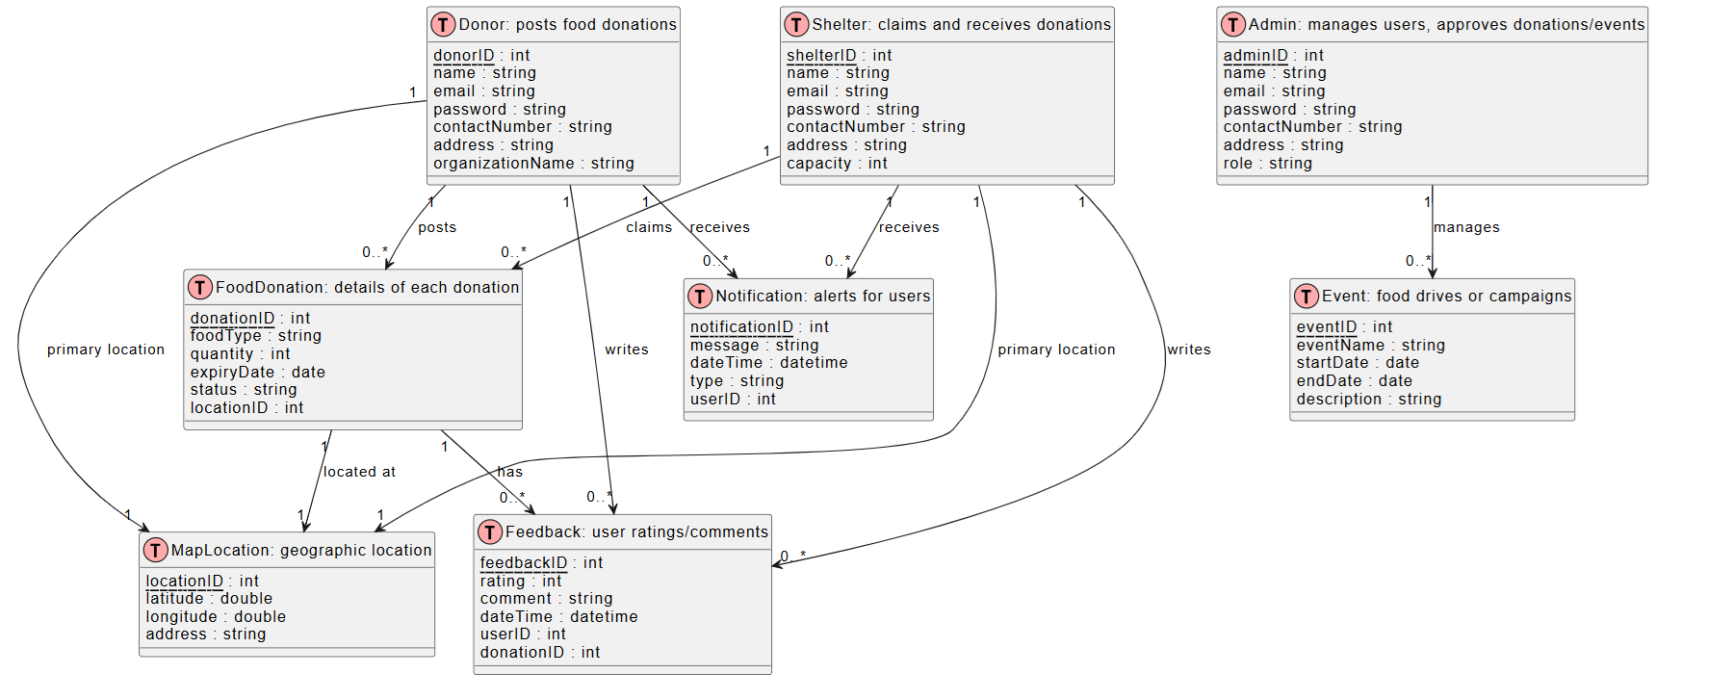

Class Diagram
The class diagram represents the structure of the application by showing the main classes, their attributes, methods, and relationships.

Class, Attribute and Method Table
Class Name | Attributes | Methods
Donor | donorID, name, email, password, contactNumber, address, organizationName | postFoodDonation(), login(), logout(), updateProfile()
Shelter | shelterID, name, email, password, contactNumber, address, capacity | viewDonations(), claimDonation(), login(), logout(), updateProfile()
Admin | adminID, name, email, password, contactNumber, address, role | approveUser(), approveDonation(), createEvent(), handleReport(), login(), logout(), updateProfile()
FoodDonation | donationID, foodType, quantity, expiryDate, status, location (MapLocation) | updateStatus()
MapLocation | latitude, longitude, address | —
Event | eventID, eventName, startDate, endDate, description | createEvent(), updateEvent(), deleteEvent()
Notification | notificationID, message, dateTime, type | sendNotification()
Feedback | feedbackID, rating, comment, dateTime | submitFeedback()

Relationships
- Donor → FoodDonation (1-to-many)
- Shelter → FoodDonation (1-to-many)
- Admin → Event (1-to-many)
- User → Notification (1-to-many)
- User → Feedback (1-to-many)
- FoodDonation → Feedback (1-to-many)
- FoodDonation → MapLocation (1-to-1)
- Donor → MapLocation (1-to-1)
- Shelter → MapLocation (1-to-1)

Class Diagram
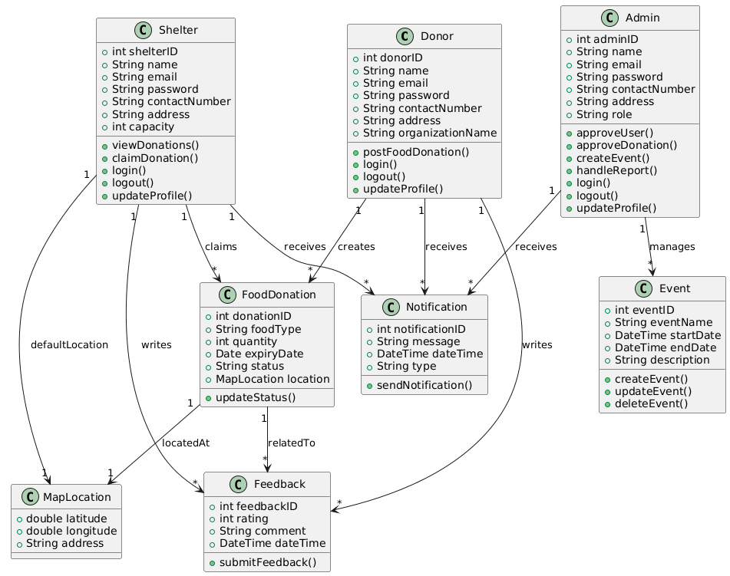

Implementation – Developing the Agile Plan

Agile and Scrum Approach
The development of the Food4Need system follows an Agile Scrum methodology, with iterative development in three sprints of three weeks each. This approach ensures that:
- Iterative: Use cases are developed in small, manageable groups so that multiple features can be implemented concurrently.
- Agile: The plan remains flexible, allowing changes in response to new information, requirements updates, or external constraints.
- Scrum: Specific roles are assigned (Product Owner, Scrum Master, Developers), sprints are planned, and progress is tracked through daily standups and sprint reviews.

Assumptions:
- Each sprint is three weeks long.
- The development team consists of two developers, a Product Owner (Anamika), and a Scrum Master (Sukhpal).
- The priority is to implement core functionalities first, followed by supporting features and enhancements.

Sprint Breakdown
Sprint | Duration | Goals / Use Cases | Tasks | Responsible Members | Expected Deliverables
Sprint 1 | Week 1–3 | Core user account and donation features | - Implement Register/Login for Donors and Shelters  - Manage Profile  - Post Food Donation Listing  - System validation & notifications | Anamika: Frontend forms, UI mockups  Sukhpal: Backend validation, database setup | Functional login/register system, donor/shelter profile management, donation submission prototype
Sprint 2 | Week 4–6 | Donation tracking and claim features | - View Available Donations  - Claim Donation  - Food Expiry Notification  - Admin approval of donations | Anamika: UI updates for donation list and claim  Sukhpal: Backend approval workflow, notification system | Donation listing with live claim, expiry alerts, admin approval workflow implemented
Sprint 3 | Week 7–9 | Advanced features, feedback, events, and dashboard | - Feedback/Review submission  - Live Map View  - Create/Edit/Delete Events  - Community impact dashboard  - Testing & bug fixes | Anamika: Mapintegration, event UI, dashboard  Sukhpal: Backend integration, data analytics, final testing | Fully functionalapp prototype with donation, claims, map, events, feedback, and dashboard

Scrum Roles and Responsibilities
Role | Member | Responsibilities
Product Owner | Anamika | Define product vision, prioritize backlog, approve features, maintain requirements documentation
Scrum Master | Sukhpal | Facilitate sprint planning, remove blockers, track progress, ensure Agile best practices are followed
Developers | Anamika & Sukhpal | Implement features, perform unit testing, integrate frontend and backend, update documentation

Agile Plan Notes
- Iterative Development: Each sprint delivers working components that can be reviewed and improved in subsequent sprints.
- Flexibility: Requirements may change based on client feedback, testing results, or technical feasibility.
- Daily Standups: Short daily meetings will track progress, discuss challenges, and adjust tasks.
- Sprint Review and Retrospective: At the end of each sprint, completed features will be reviewed and feedback will be incorporated for the next sprint.
- Testing: Unit, integration, and usability testing are integrated into each sprint to ensure quality throughout development.

Food4Need Agile Implementation Plan

Sprint | Duration | Use Case / Feature | Task Description | Responsible Member | Status | Start Date | End Date | Expected Deliverables
Sprint 1 | Week 1–3 | Register / Login (User) | Implement donor and shelter registration and login functionality | Anamika | In Progress | 01-Dec-2025 | 21-Dec-2025 | Functional login/register system
Sprint 1 | Week 1–3 | Manage Profile | Enable users to update personal details and preferences | Sukhpal | Done | 01-Dec-2025 | 21-Dec-2025 | Profile management module
Sprint 1 | Week 1–3 | Post Food Donation Listing | Create form for posting donations with validation | Anamika | Pending | 01-Dec-2025 | 21-Dec-2025 | Donation submission prototype
Sprint 2 | Week 4–6 | View Available Donations | Display donations to shelters with filtering options | Anamika | Done | 22-Dec-2025 | 11-Jan-2026 | Donation listing module
Sprint 2 | Week 4–6 | Claim Donation | Allow shelters to claim donations and update status | Sukhpal | In Progress | 22-Dec-2025 | 11-Jan-2026 | Donation claim system
Sprint 2 | Week 4–6 | Food Expiry Notification | Notify donors/shelters about soon-to-expire food | Anamika | In Progress | 22-Dec-2025 | 11-Jan-2026 | Notification feature for expiry
Sprint 2 | Week 4–6 | Approve Donation Listings | Admin verifies and approves donations | Sukhpal | In Progress | 22-Dec-2025 | 11-Jan-2026 | Admin approval workflow
Sprint 3 | Week 7–9 | Feedback / Review | Implement feedback submission and viewing | Anamika | Done | 12-Jan-2026 | 01-Feb-2026 | Feedback module functional
Sprint 3 | Week 7–9 | Live Map View | Integrate map showing nearby donors, shelters, and urgent donations | Sukhpal | Done | 12-Jan-2026 | 01-Feb-2026 | Live map interface
Sprint 3 | Week 7–9 | Create/Edit/Delete Events | Admin manages events and campaigns | Anamika | Done | 12-Jan-2026 | 01-Feb-2026 | Event management module
Sprint 3 | Week 7–9 | Community Impact Dashboard | Display statistics on saved food and redistribution | Sukhpal | In Progress | 12-Jan-2026 | 01-Feb-2026 | Dashboard showing app impact
Sprint 3 | Week 7–9 | Testing & Bug Fixes | Perform unit, integration, and usability testing | Anamika & Sukhpal | In Progress | 12-Jan-2026 | 01-Feb-2026 | Tested, stable prototype

References
- UNEP – UN Environment Programme (2021). Food Waste Index Report 2021.
- Food Banks Canada (2025). HungerCount 2025 Report.
- Second Harvest (2022). Food Rescue and Recovery Best Practices.
- ReFED (2020). Roadmap to Reduce U.S. Food Waste.
- Feed Ontario (2023). Food Bank Network Operations Report.
- Too Good To Go (2023). App Overview and Features.
- Olio (2023). Community Food Sharing Platform Overview.

